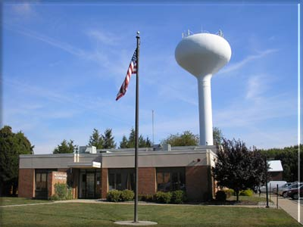 **\*\* ALL FIELDS ARE REQUIRED TO BE FILLED OUT, OR APPLICATION WILL NOT BE ACCEPTED\*\***

*Upper Southampton Municipal Authority*

*945 Street Road, P.O. Box 481*

*Southampton, PA 18966*

*(215) 364-1390 Fax (215) 364-9410*

**CERTIFICATION REQUEST**

Property address ________________________________________________________

Seller(s) Name(s) _______________________________________________________

Seller Phone ____________________ Seller email_____________________________

Forwarding address______________________________________________________

Title Co./Conveyancer ________________________ Phone # ____________________

Realtor Name ___________________________ Phone #_________________________

Date of Settlement__________________ Time of Settlement ________ am pm

Certification sent to__________________________ Fax:__________________________

Buyer Name(s) __________________________________________________________

Buyer Phone____________________ Buyer email ______________________________

**IF SETTLEMENT DATE CHANGES, YOU MUST NOTIFY US IMMEDIATLEY!**

**$100 CERT FEE WILL BE REQUIRED IF NOTIFIED AFTER ORIGINAL SETTLEMENT DATE**

**Office Use Only**

Account #____________ Final Read_________Sump Inspect____Lateral Inspect______

Notes:___________________________________________________________________

_________________________________________________________________________