1. Rain Barrels (Connected to Downspouts)
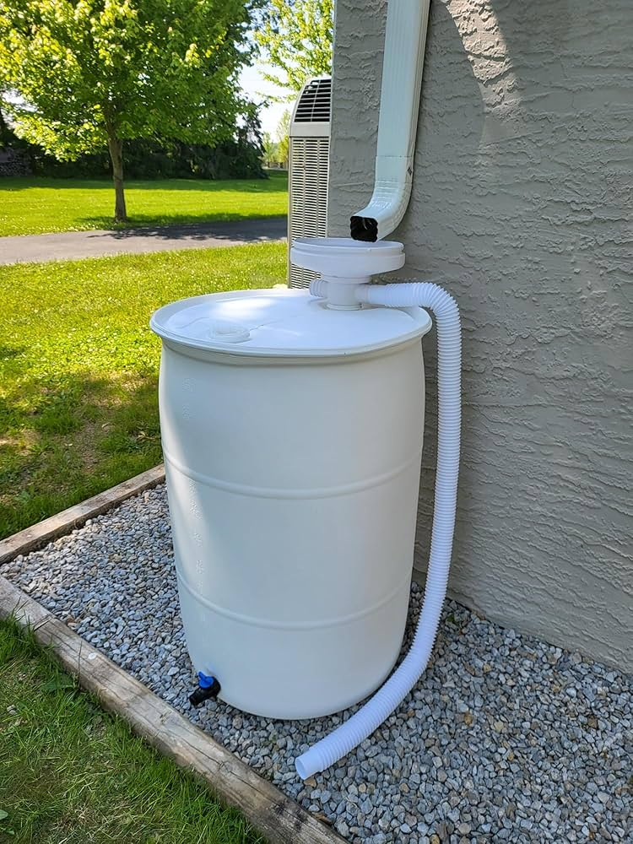

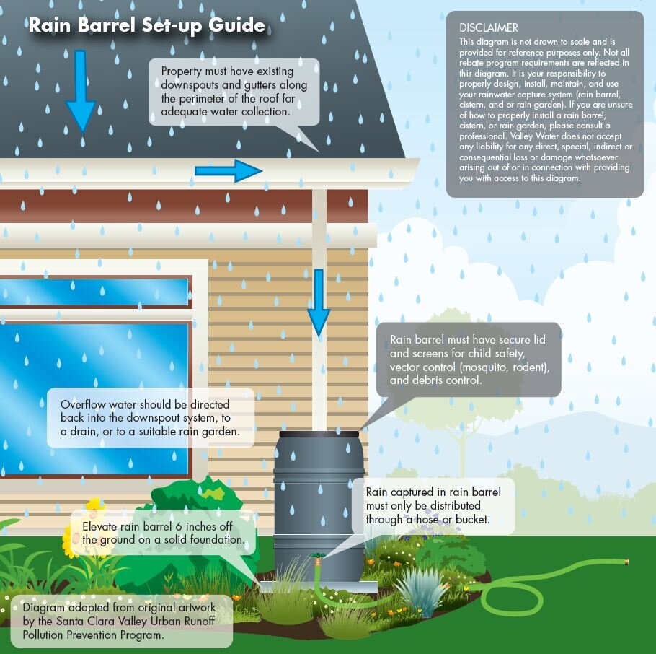

What it is: Barrels that collect roof runoff from downspouts for later use (e.g., watering gardens).
Credit Benefit: Reduces runoff volume and peak flows, lowering stormwater fees and conserving potable water. Often eligible for utility fee reductions.
2. Structural BMPs (Best Management Practices)
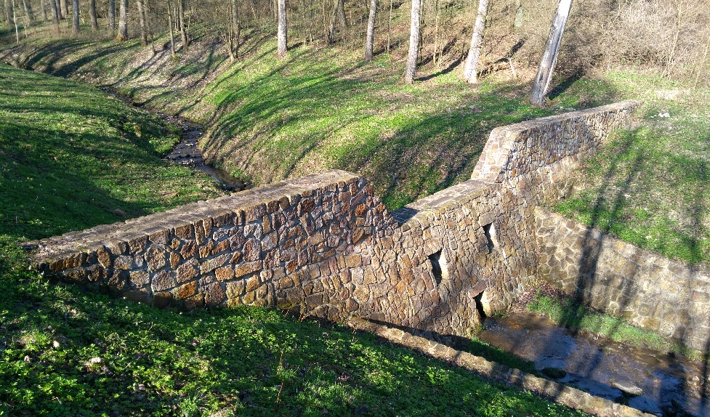

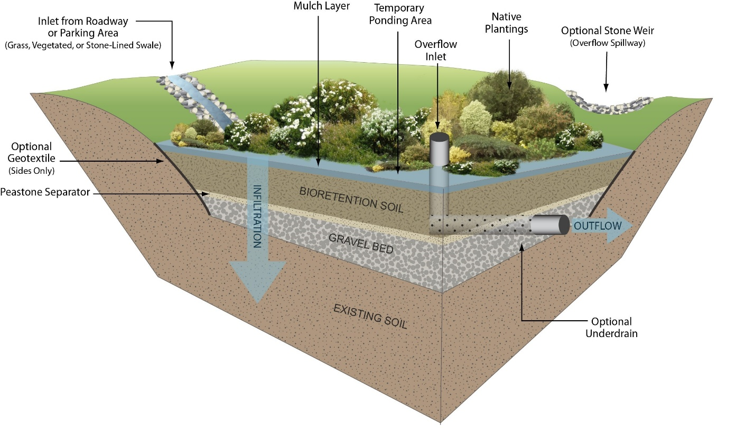

What it is: Engineered installations like detention basins, bioretention cells, infiltration trenches, and curb cuts.
Credit Benefit: Treats and detains stormwater on-site, reducing pollutant loads and storm sewer demand.

3. MS4 Public Education & Outreach
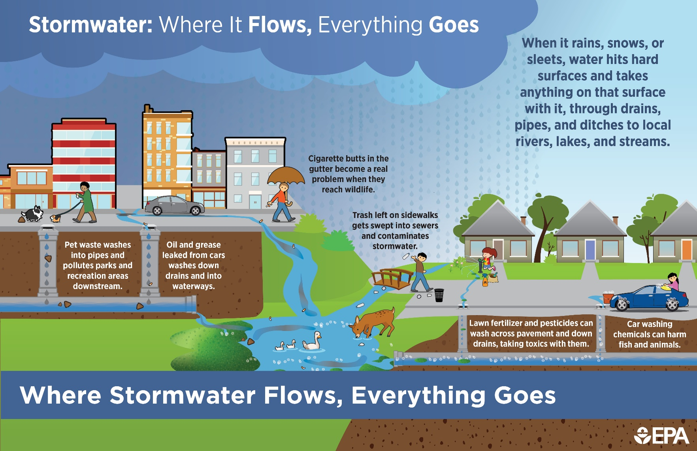

What it is: Programs that inform residents/businesses about reducing pollutants (e.g., proper fertilizer use, pet waste management).
Credit Benefit: Under MS4 permits, municipalities often earn credits by documenting outreach campaigns, workshops, and media outreach that reduce stormwater impacts.

4. Rain Gardens
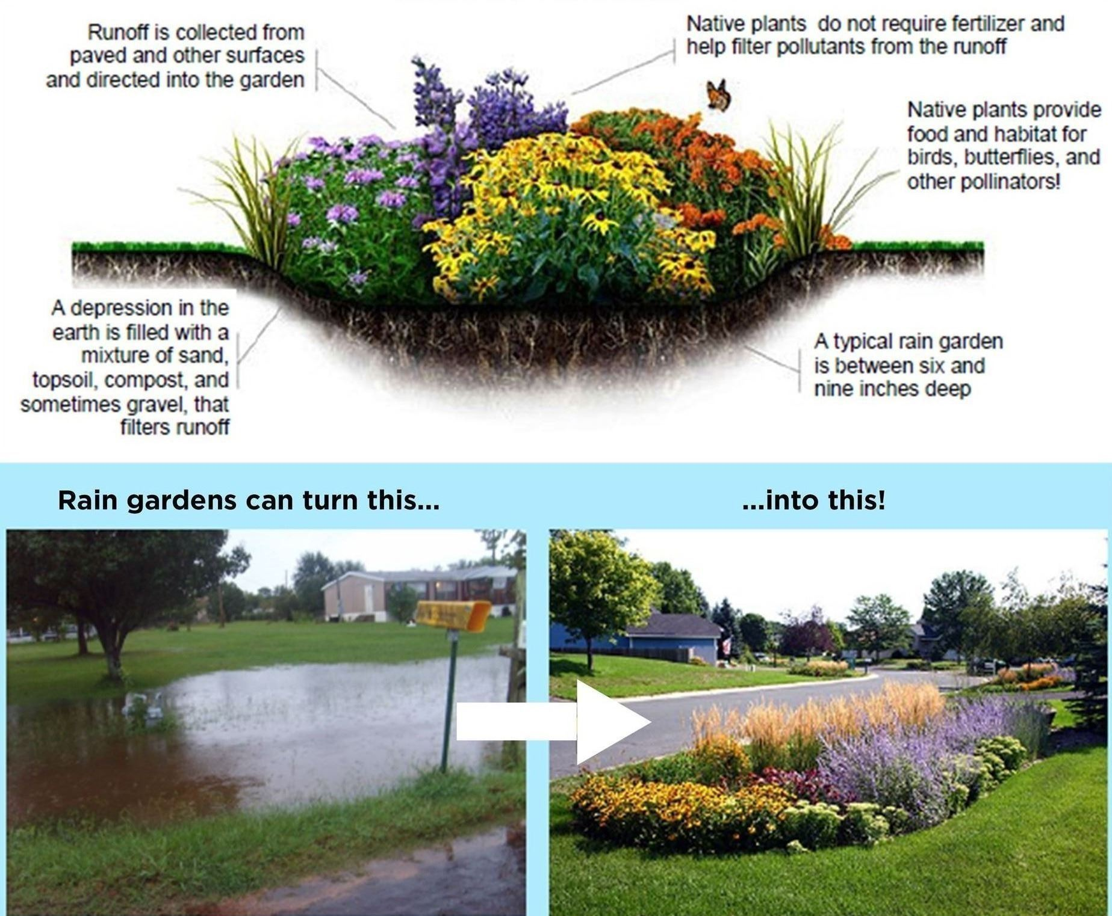

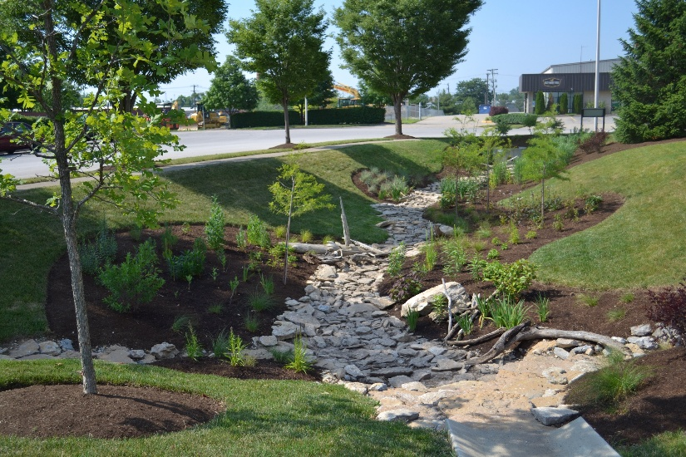

What it is: Shallow, vegetated basins that capture and infiltrate runoff from roofs and paved surfaces.
Credit Benefit: Decreases runoff volume and improves water quality; many programs offer credits or rebates for installation.
6. Tree Canopy Expansion
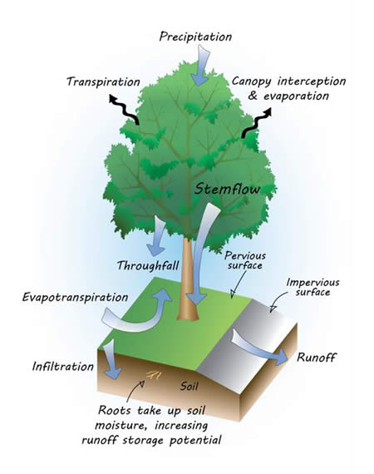

What it is: Planting trees to intercept rain, promote infiltration, and reduce peak runoff.
Credit Benefit: Credits often awarded for new tree plantings, particularly in urban areas where canopy is limited.
7. French Drains
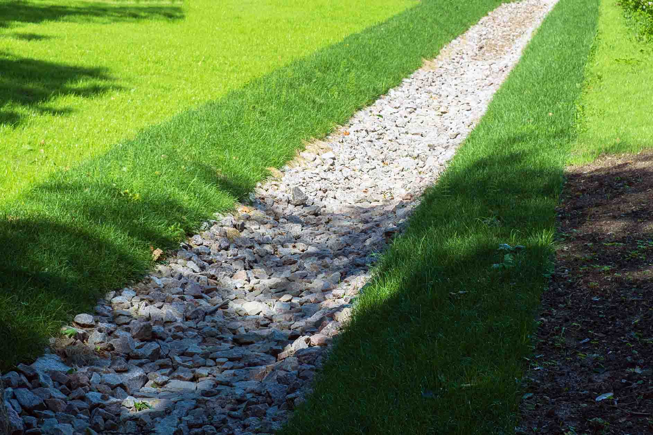

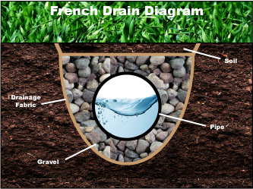

What it is: Gravel-filled trenches with perforated pipes that convey and infiltrate excess surface water.
Credit Benefit: Manages subsurface drainage and reduces runoff to storm sewers; may qualify for credits when designed to infiltrate on-site water.

